|  |  |
| --- | --- |
| Document name | Nexus Information Guide |
| Version no. | 1.0 |
| Release date | 26-Mar-15 |

| **Version No.** | **Authored / Modified by** | **Reviewed by, Date** | **Approved by, Date** | **Remark / Change History** |
| --- | --- | --- | --- | --- |
| 1.0 | Vidya Jadhav  26--Mar-15 | Not reviewed |  | Initial Document |

Contents

Nexus Pro Installation Guide 4

Nexus overview 24

1. Nexus concept 24
2. Nexus repository health checks 25

Nexus Advantages 27

1. Faster More Reliable Builds 27
2. Accelerate developer productivity and efficiency 27
3. Support for Multiple Component Types 28
4. Seamless Integration with Existing Tools 28
5. Improved Collaboration for Distributed Teams 29
6. Streamlined Release Management 30
7. Rapid Identification of Security and License Risk 31
8. Component Governance and Reporting 32
9. Improved Security 33

Nexus staging profiles 34

1. Before Nexus 34
2. Nexus Staging suite :- 34
3. Replace the release process using the Nexus Staging Suite 34

# Nexus Pro Installation Guide

**Download Sonatype Nexus pro from following link and follow the steps as mentioned below :-**

[**http://www.sonatype.org/nexus/go/**](http://www.sonatype.org/nexus/go/)

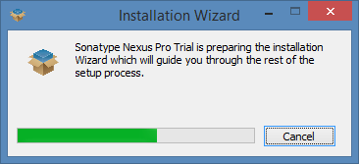

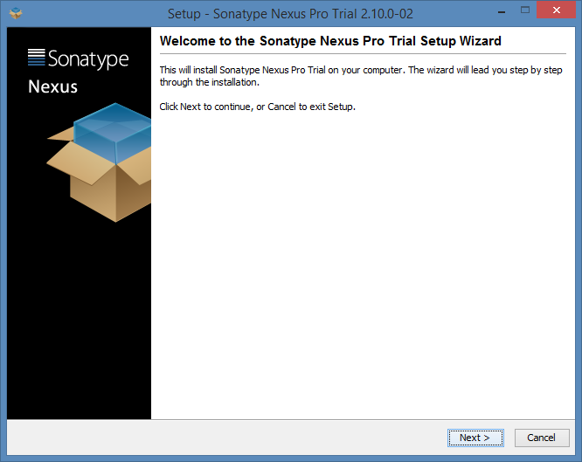

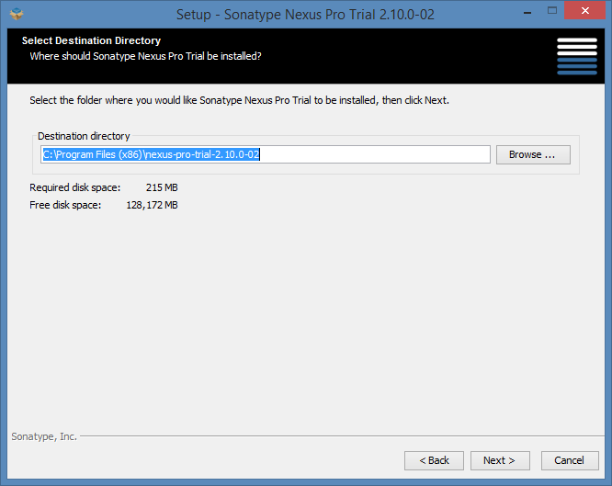

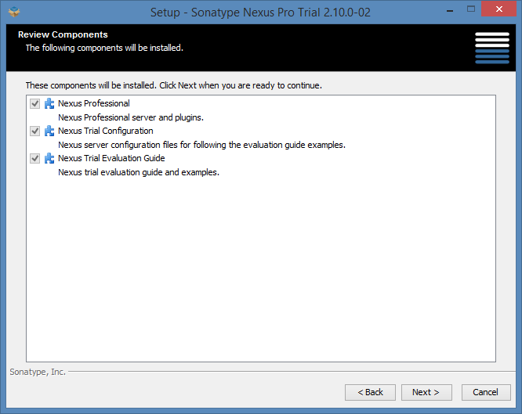

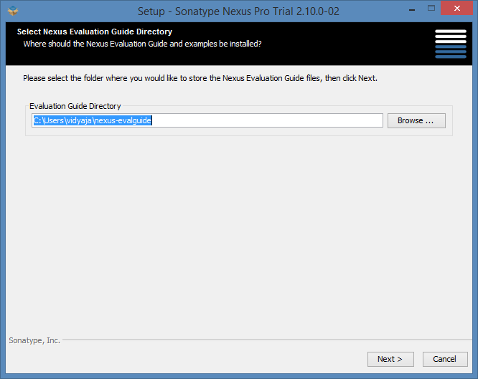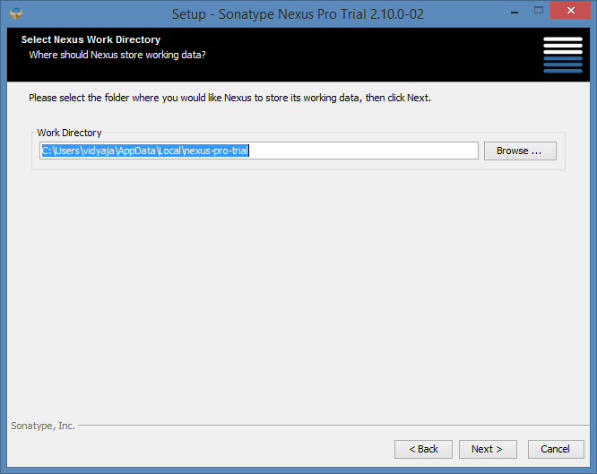

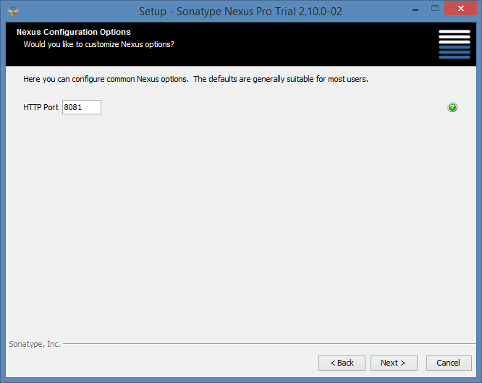

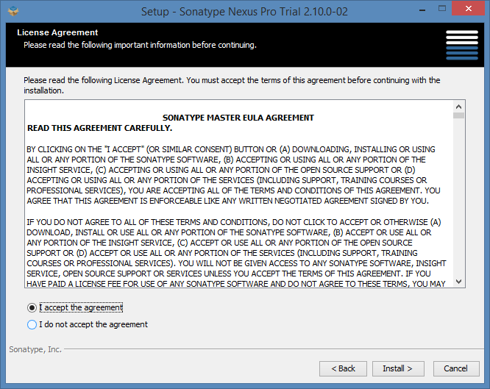

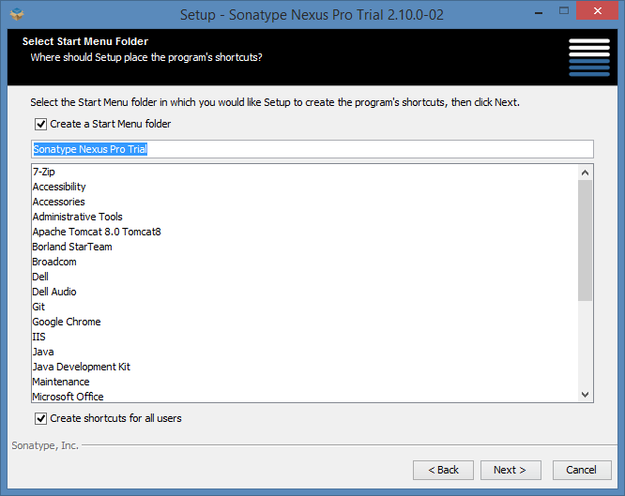

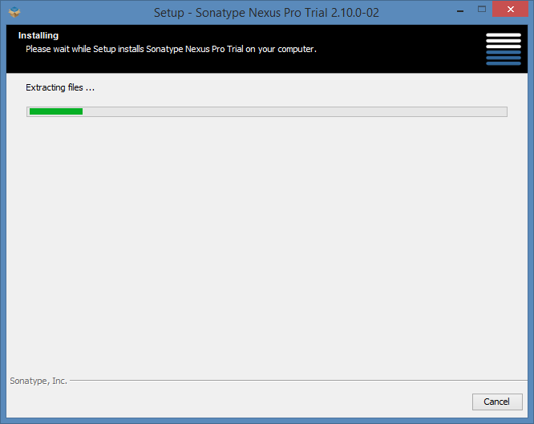

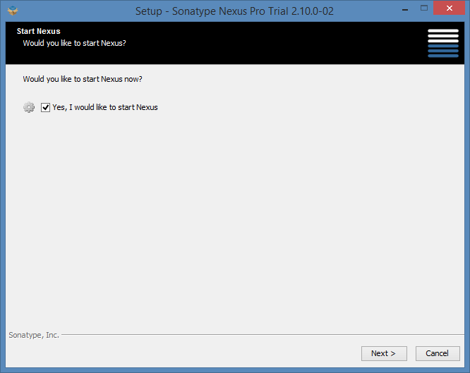

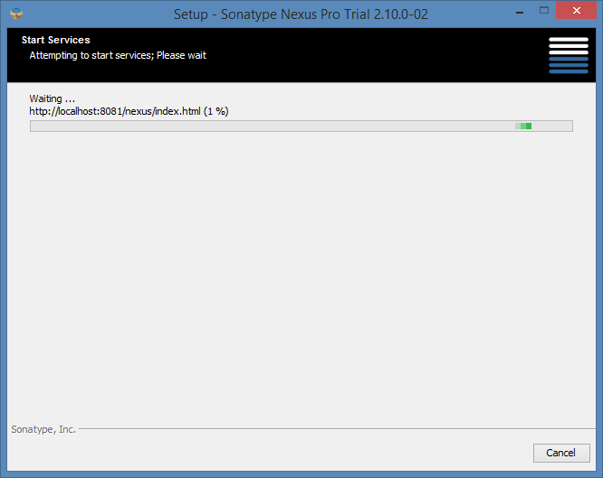

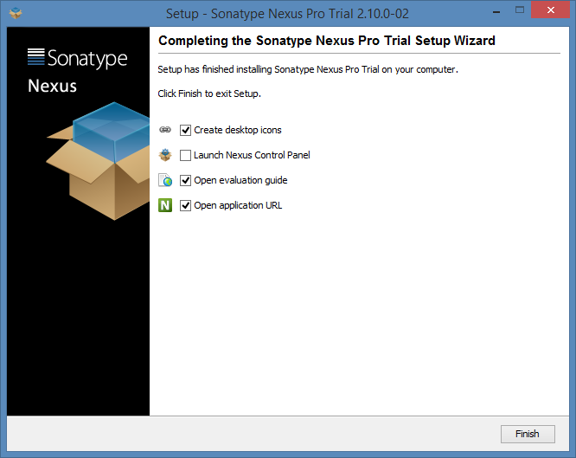

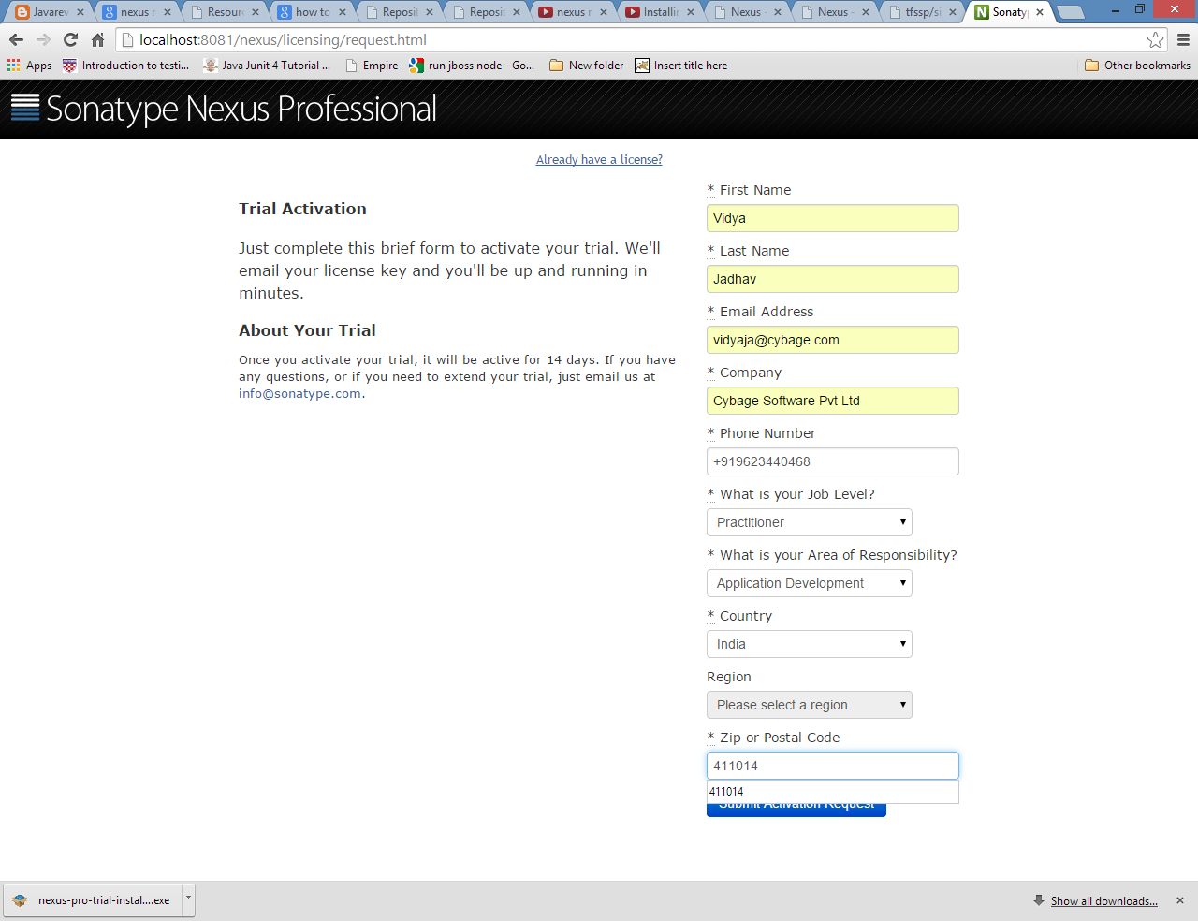

Enter activation code received in email

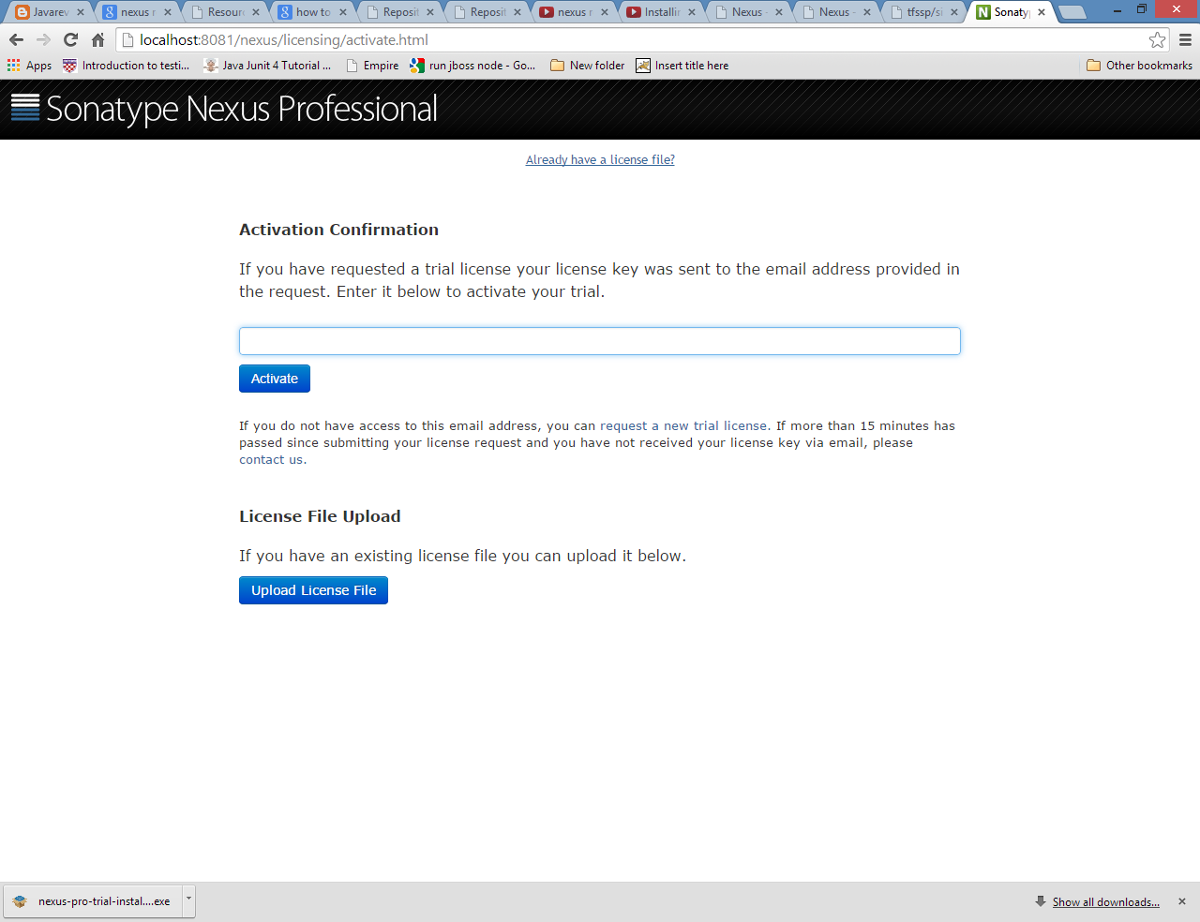

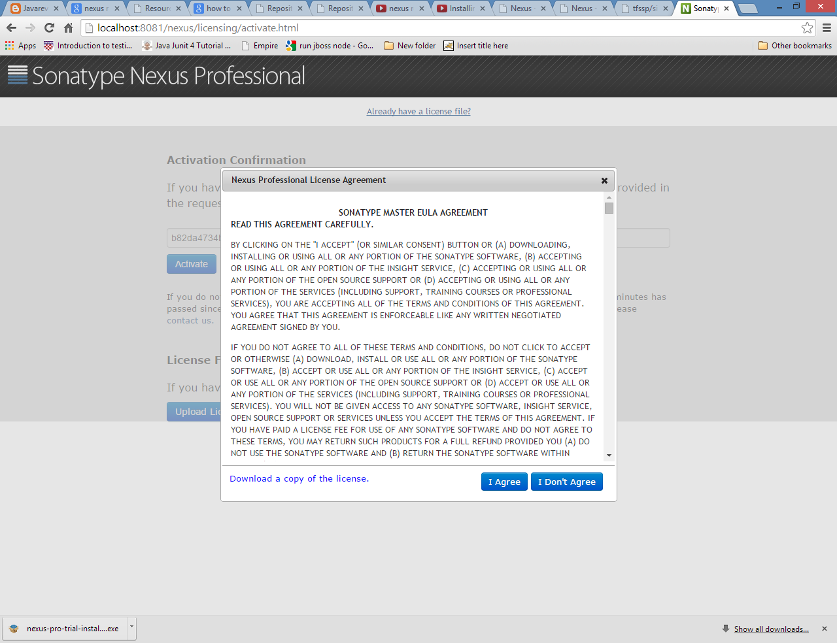

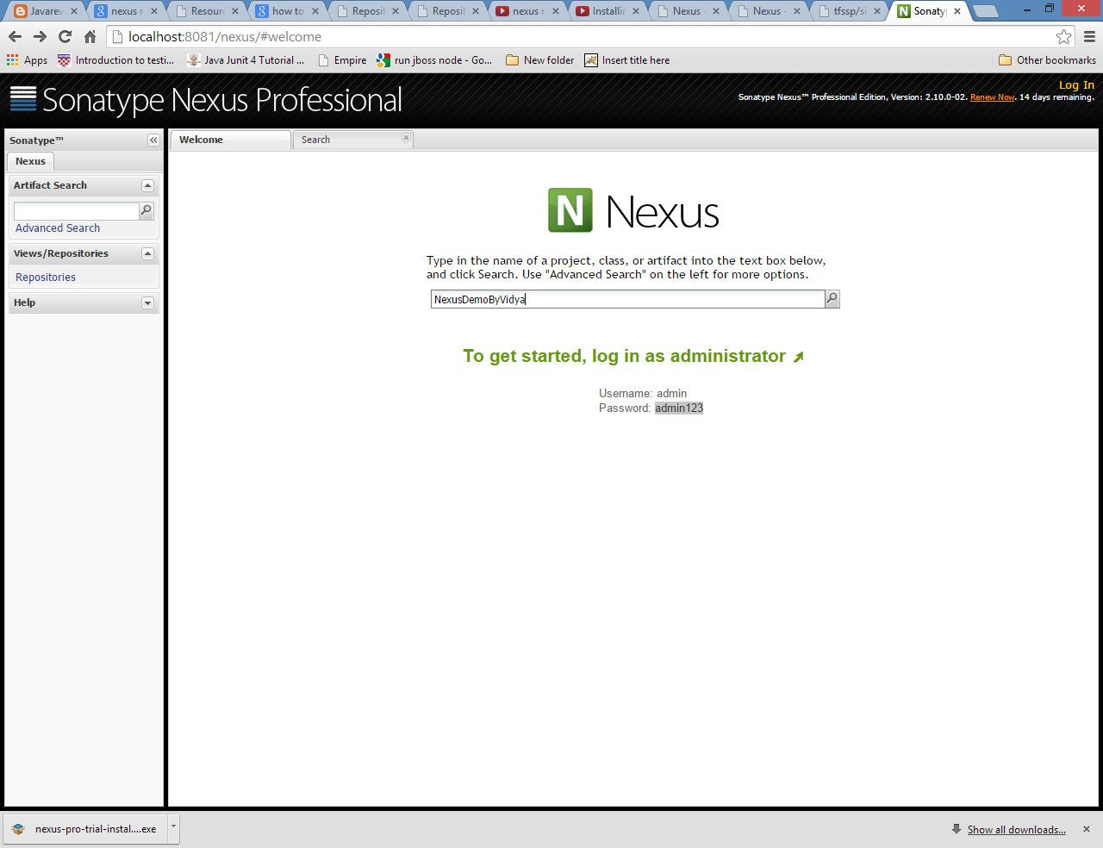

Login using default user admin and password admin123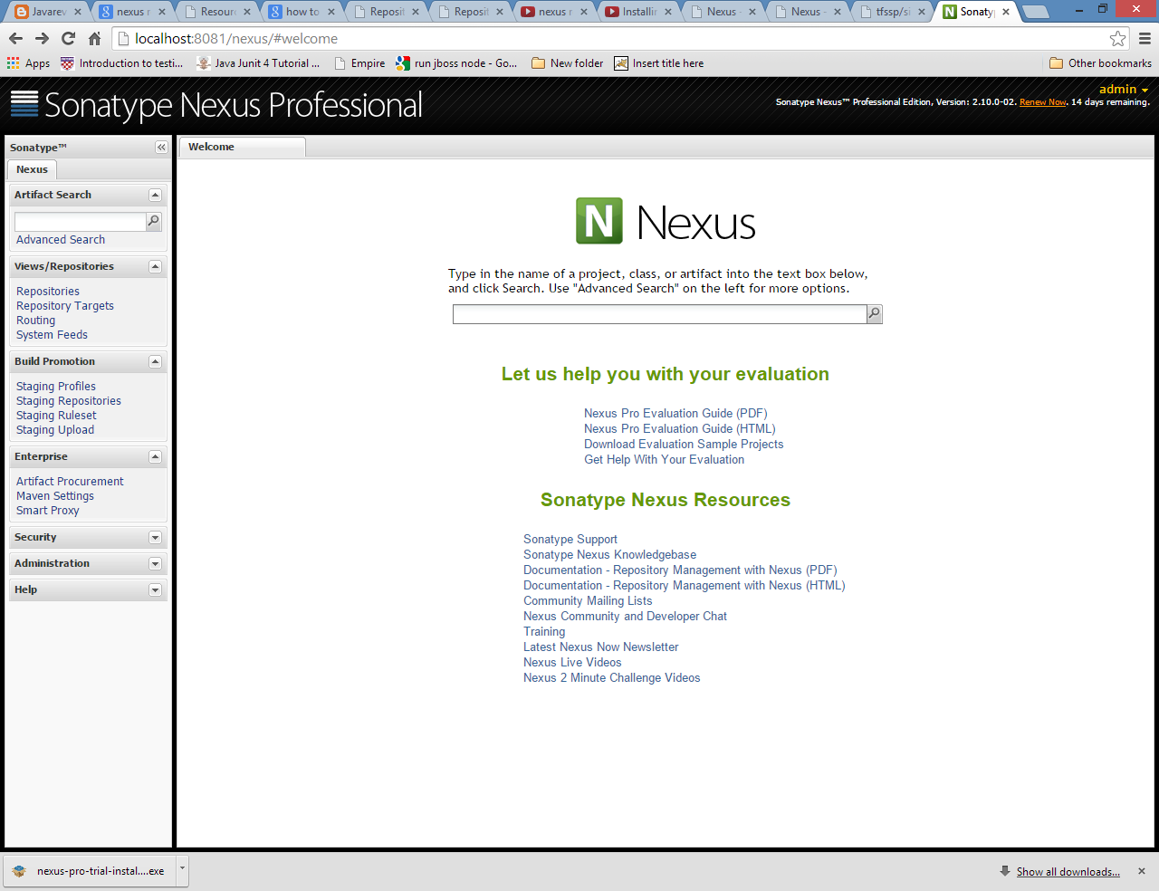

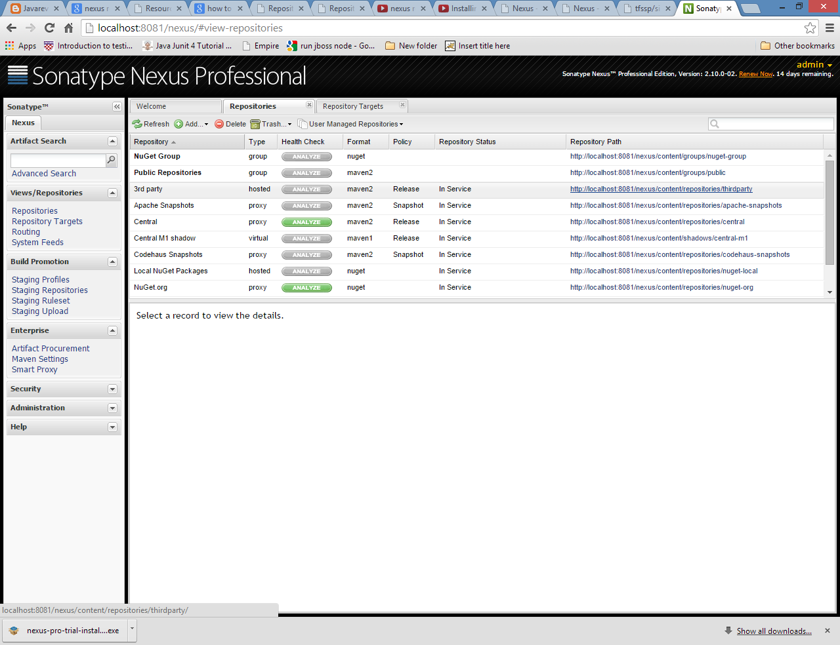

As shown below Nexus control panel can be used to start Nexus :- 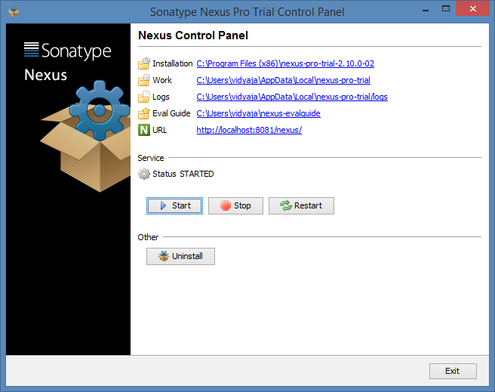

# Nexus overview

## Nexus concept

1. If your build relies on maven central repository you are wasting time and bandwidth.

If you have 500 developers everyone has to download artifacts over and over

So download Nexus and Nexus is preconfigured with proxy from maven central.

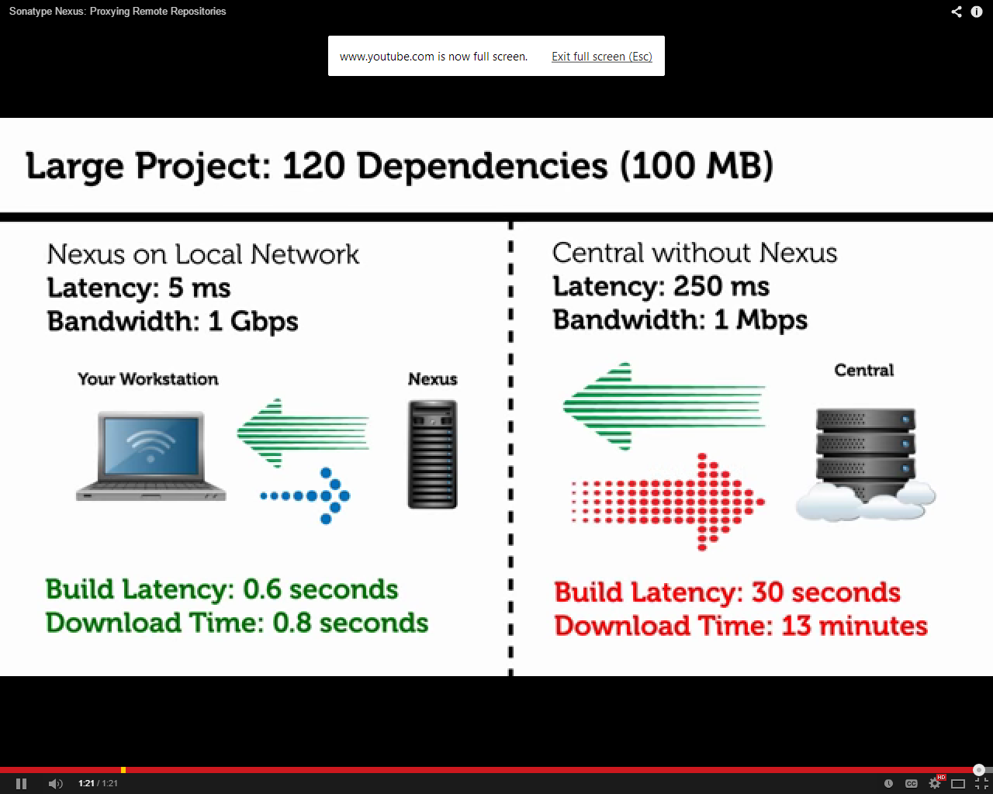

1. When we need jars from 3rd party Caching components locally eliminates the need to download dependencies over the Internet, saving time and eliminating the risk that the Internet or remote server won’t be available during the build.

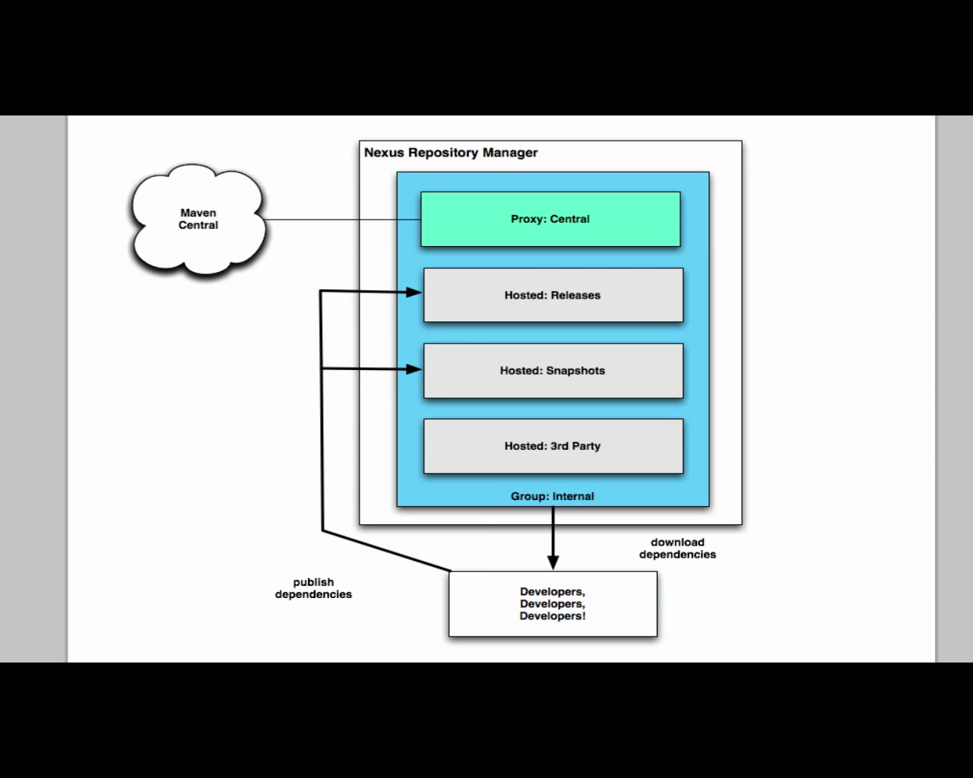

## Nexus repository health checks

Click on analyze button against repositories and check detailed report for repository health checks as shown below :

Which covers security vulnerabilities, Threat Level, Problem Code and the GAV parameters identifying the affected artifact, license expired, etc

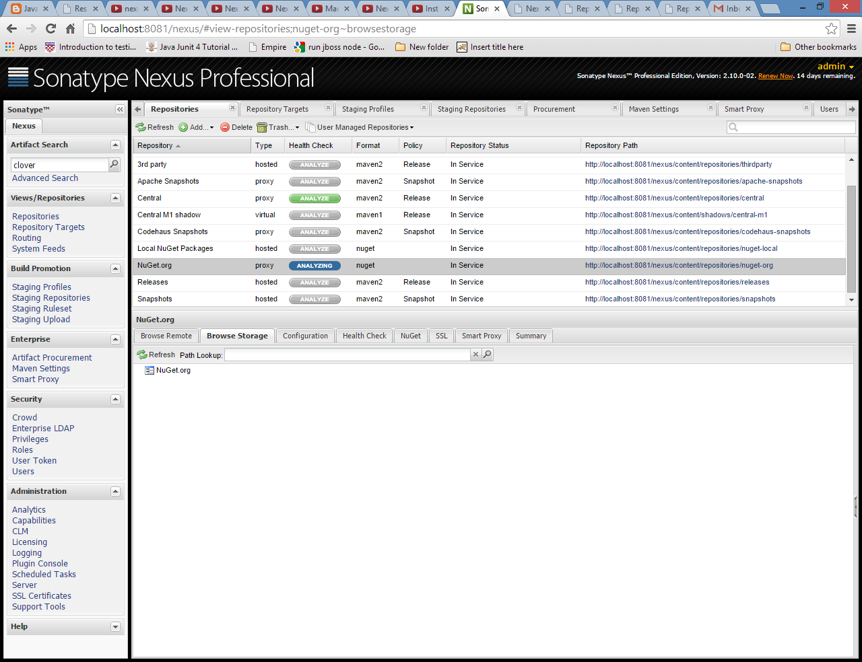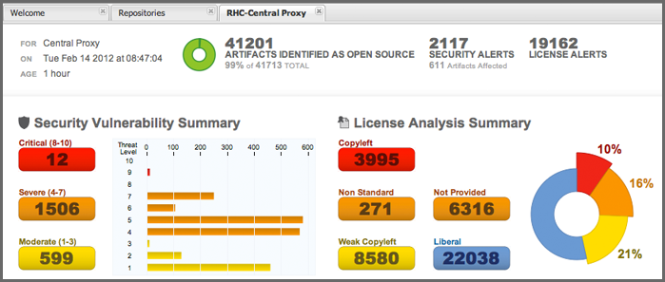

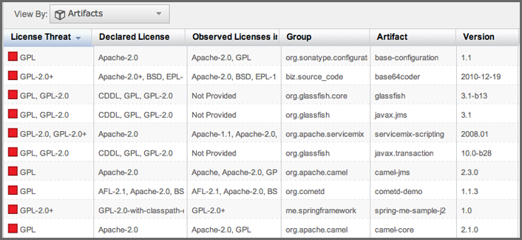

# Nexus Advantages

## Faster More Reliable Builds

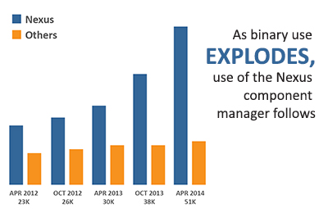

Since components now comprise up to 90 percent of a typical application, development teams need tools to reduce complexity and accelerate productivity. As component usage grows, so does the popularity of Nexus Repositories.

Accelerate developer productivity and efficiency

* Retrieve components once, cache locally, access quickly
* Deploy your own artifacts to hosted repositories
* Share binaries, snapshots and releases between groups of developers
* Improve visibility to and control of approved components

## Support for Multiple Component Types

[Proxy and host the most popular binaries in one place](http://www.sonatype.com/system/images/W1siZiIsIjIwMTQvMTAvMjkvMTgvNDcvNTkvNTkzL3B0X25leHVzX292ZXJ2aWV3X2Z1bGwyLmpwZyJdXQ/pt-nexus-overview-full2.jpg)

* Supports Java, NuGet and npm. Support for Gems, and PyPi coming soon*
* Comprehensive repository support for Maven, NuGet, OSGi, Yum, and P2

*[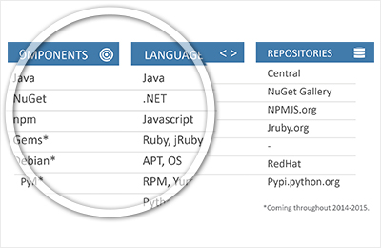](http://www.sonatype.com/system/images/W1siZiIsIjIwMTQvMTAvMjkvMTgvNDcvNTkvNTkzL3B0X25leHVzX292ZXJ2aWV3X2Z1bGwyLmpwZyJdXQ/pt-nexus-overview-full2.jpg)*

## Seamless Integration with Existing Tools

REST-based integration and services leverage your current dev tools

* Automate interactions with leading development tools such as Eclipse, Hudson, Jenkins, Puppet, Chef, Docker, RunDeck, and more
* Integrate Nexus REST services into your workflows
* Supports the Java Virtual Machine (JVM) ecosystem, including Gradle, Ant, Maven, SPT, Ivy, Leiningen.

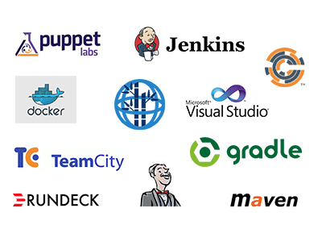

## Improved Collaboration for Distributed Teams

[*Smart proxy keeps distributed teams in sync*](http://www.sonatype.com/system/images/W1siZiIsIjIwMTQvMDgvMjEvMTQvNDYvMjIvODk0L3B0X25leHVzX292ZXJ2aWV3X2Z1bGw0LmpwZyJdXQ/pt-nexus-overview-full4.jpg)

* Your Nexus license allows unlimited servers for scaling your deployments including production and testing instances - no extra cost!
* Provide immediate availability of upstream artifacts to downstream Nexus instances, keeping all development locations in sync
* Synchronize artifact additions, deletions, and changes across all trusted Nexus instances

*[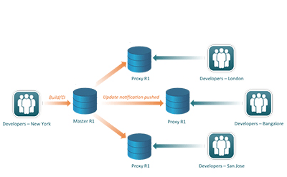](http://www.sonatype.com/system/images/W1siZiIsIjIwMTQvMDgvMjEvMTQvNDYvMjIvODk0L3B0X25leHVzX292ZXJ2aWV3X2Z1bGw0LmpwZyJdXQ/pt-nexus-overview-full4.jpg)*

[*Enlarge image*](http://www.sonatype.com/system/images/W1siZiIsIjIwMTQvMDgvMjEvMTQvNDYvMjIvODk0L3B0X25leHVzX292ZXJ2aWV3X2Z1bGw0LmpwZyJdXQ/pt-nexus-overview-full4.jpg)

## Streamlined Release Management

*Improved build promotion and staging*

* Post a collection of related, staged artifacts which can be tested, promoted, or discarded as a unit
* Streamline oversight and approval of workflows for release candidates
* With Nexus Pro CLM’s policy edition, promotion and staging constraints and actions can be configured
* Nexus Pro policy violations can trigger warnings, notify specific personnel, or even prevent a release.
* 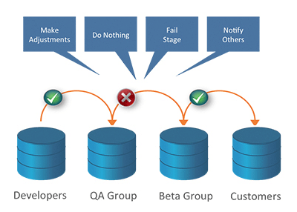

## Rapid Identification of Security and License Risk

* [*A Nexus Exclusive: Constantly updated and accurate component intelligence is built right into Nexus*](http://www.sonatype.com/system/images/W1siZiIsIjIwMTQvMDgvMjEvMTQvNDcvMjEvNjc2L3B0X25leHVzX292ZXJ2aWV3X2Z1bGw2LmpwZyJdXQ/pt-nexus-overview-full6.jpg)
* Instantly identify if any component has known security or license vulnerabilities, right from your Nexus interface
* Discover if a newer, safer version of a component already exists. Avoid risk and rework by making smart decisions early on.
* With Nexus Pro CLM, risk profiles can assist in formulating and improving open source policies
* Run a Repository Health Check to analyze the vulnerabilities in artifacts already in your repository

*[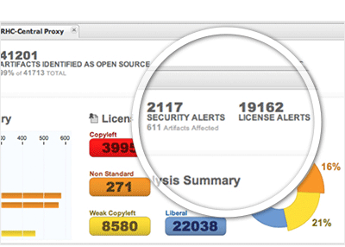](http://www.sonatype.com/system/images/W1siZiIsIjIwMTQvMDgvMjEvMTQvNDcvMjEvNjc2L3B0X25leHVzX292ZXJ2aWV3X2Z1bGw2LmpwZyJdXQ/pt-nexus-overview-full6.jpg)*

[*See more details*](http://www.sonatype.com/system/images/W1siZiIsIjIwMTQvMDgvMjEvMTQvNDcvMjEvNjc2L3B0X25leHVzX292ZXJ2aWV3X2Z1bGw2LmpwZyJdXQ/pt-nexus-overview-full6.jpg)

More than 32,000 Repository Health Checks are processed every day by users worldwide, making it one of the most popular Nexus Pro features.

## Component Governance and Reporting

[With Nexus Pro CLM Edition, gain visibility and control over components used across develo*pment*](http://www.sonatype.com/system/images/W1siZiIsIjIwMTQvMDgvMTQvMjAvMjYvMDAvNjk4L3B0X25leHVzX292ZXJ2aWV3X2Z1bGw3LmpwZyJdXQ/pt-nexus-overview-full7.jpg)

* Define rules for open source component use related to application types, license risk, security vulnerabilities, and more
* Trigger alerts or actions on policy violations
* Gain visibility to alternative component choices following violation notices

*[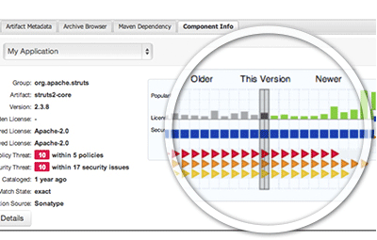](http://www.sonatype.com/system/images/W1siZiIsIjIwMTQvMDgvMTQvMjAvMjYvMDAvNjk4L3B0X25leHVzX292ZXJ2aWV3X2Z1bGw3LmpwZyJdXQ/pt-nexus-overview-full7.jpg)*

## Improved Security

*Protect access to all of your components*

* Prevent man-in-the-middle attacks and maintain privacy over development with encrypted SSL communications
* Support common LDAP user/group mappings across the enterprise
* Apply user token authentication and role-based access controls to reduce insider threat risks

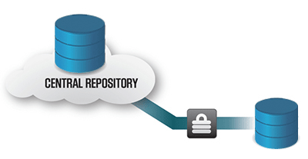

# Nexus staging profiles

## Before Nexus

* How staging supports managed releases
* Before that study “Common pattern in Enterprise builds”
* Most enterprise begin life with focused applications and over the years application becomes complex. They gather complexity
* Most organizations have monolithic builds
  + Building the entire codebase
  + The build is brittle
  + Small bugs are magnified
  + Resists changes
  + Highly coupled
* Build is not scalable to the increased groups in the team
* So here Nexus come in the picture

## Nexus Staging suite :-

* A workflow for managed releases
* Automatic notification of a deployment
* Nexus professional as a collaboration point
* You can make the release process more powerful using staging

## Replace the release process using the Nexus Staging Suite

Follow following steps to setup staging profiles in nexus also refer the snapshots for your reference:

1. Setup Repository target
2. Create staging profile
   1. Add Repository target as the one created
3. Copy the Deploy URL and paste it in POM.xml as follows :

<distributionManagement>

<repository>

<id>nexus</id>

<url>http://localhost:8081/nexus/service/local/staging/deploy/maven2</url>

</repository>

</distributionManagement>

1. Run maven clean deploy on project root folder :

Which deploys artifacts from maven to Nexus

1. Browse Repository targets. Downloaded artifacts can be track from repository targets.

* 
 